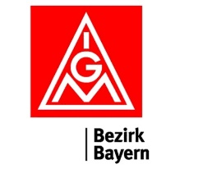

Wiener Memorandum expert meeting, 7/11/2023

Venue and accommodation: H-Győr, Hotel Famulus (https://famulushotel.hu/das-hotel)
Proposed topics to discuss and then put forward for presidential meetings:
- Workers from 3rd countries in the industry
  - legislation: how is it look like in the WM countries, what should be changed, what are the priorities
  - trends: what is the current situation, how is the short and medium term looks like, from which countries, etc.
  - organizing: existing experiences, practices, possible cooperation with the sending countries’ trade unions, involvement of IndustriAll Europe

- Transition in the automotive industry - Development of battery manufacturing
  - investments: from which countries (cooperation with these countries’ unions), companies, number of workers in the industry,
  - occupational health and safety issues: legislation, existing experience with companies, possible problems, risks
  - future of the industry - other solutions than electric cars: synthetic fuels or hydrogen, trade union priorites (develompents since our ’Moving Forward’ declaration in 2021)

- Ways of future cooperation in the Wiener Memorandum Group
  - EU projects: proposed topics (e.g. topics from above)
  - Inzell seminar: topics to discuss, participants
Timetable
6/11/2023 – Dinner at 18.30 at Szalai Vendéglő (9022 Győr, Kisfaludy utca 34.) – meeting directly at the restaurant or at the hotel reception at 18.00 (15 minutes walk)
7/11/2023 – meeting from 9 to 17, dinner at 18.30 at Westy Restaurant (9022 Győr, Móricz Zsigmond rkt. 2. - 20 minutes walk from the Hotel)
8/11/2023 - Departure

