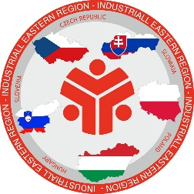

To:
Members of industriAll Europe Eastern Region
industriAll Europe member organisations from Ukraine
IndustriAll Europe

Prague, 15.11. 2023

IndustriAll Europe Eastern Region Meeting, Prague / Czech Republic
28.11.2023

Draft Agenda

- Welcome and introduction of the agenda, Roman Ďurčo
- Situation and news from industriAll Europe, including the preparation of the Executive committee - the position of the Eastern Region on policies and policy documents of industriAll Europe, Judith Kirton-Darling
- Changes in the industriAll Europe secretariat / election of Luc to ITUC, Judith Kirton-Darling
- Campaign for Industrial Jobs/Campaign focused on the EP elections – requirements, Judith Kirton-Darling
- Development and implementation of the directive on the European minimum wage: SWP CBSP will discuss national seminars focused on the implementation of this directive, Judith Kirton-Darling
- Integration of Ukrainian members into IE/use of membership of the EU-Ukraine Domestic Advisory Group Judith Kirton-Darling
- The social agreement for just transition. Future after the elections in Poland, KADRA
- The situation in the countries of the Eastern region – reports from individual countries, representative of individual countries
- Others

After each agenda issue the discussion (questions & answers) will follow.

Timeframe of the meeting:

27.11.2023

Late afternoon – arrival of participants
Free time in Prague

28.11.2023

09:00 Beginning of the meeting

10:30 – 11:00 Coffee break

11:00 – 12:30 Continuation of the meeting

12:30 – 14:00 Lunch break

14:00 – 15:30 Continuation of the meeting

15:30 – 16:00 Coffee break

16:00 – 18:00 Continuation of the meeting

18:30 Dinner at the invitation of Czech trade unions

29.11.2023

Departure after the breakfast

